**Faraday’s Law**

**Pre-lab questions:**

1. What is the goal of this experiment? What physics and general science concepts does this activity demonstrate?
2. What are three variables that can be changed to change the magnetic flux through a coil of wire?
3. What is the effect on the EMF of increasing the number of turns of wire from $N=1$ ­ to $N=400$?
4. Do you expect the area under the first peak to have an equal magnitude to the area under the second peak? Explain.

**Equipment:**

* PASCO 850 universal interface
* Voltage sensor
* Bar magnets (alnico)
* AC/DC Electronics Lab Coil (N=600 turns)
* Ruler
* Connecting wires
* Magnaprobe (magnet gyroscope)

The goal of the experiment is to measure the electromotive force induced in a coil by a magnet dropping through the coil. Dropping the magnet through the coil causes a changing magnetic flux. You will calculate the area under the curve to find the flux through the coil when the magnet moves in (incoming flux) and the magnet moves out (outgoing flux) to compare the fluxes and calculate the magnetic induction of a magnet.

**Introduction:**

The Faraday’s Law of induction states that an induced electromotive force (EMF) is produced by a changing magnetic flux **Ф** through a circuit. This means that we can induce an electromotive force (with an associated potential difference and current) without the use of a battery or power supply. The magnetic flux **Ф** is defined as the magnetic induction ***B*** through the area of loop ***A***:

$$\begin{aligned}Φ=B ∙A\cos{θ}\#\left(1\right)\end{aligned}$$

where θ is the angle between the magnetic induction vector and the normal to the area. The units for flux are Webers [$Wb = T∙m^{2}=V∙ sec]$

The magnitude of the induced EMF ($E$) induced in a single loop of wire is equal to the rate of change in the magnetic flux:

$$\begin{aligned}E=-\frac{ΔΦ}{Δt}\#\left(2\right)\end{aligned}$$

In this equation the sign minus represents the direction of induced EMF according to the Lentz’s law.

Lentz’s law states that induced EMF produces a current that tends to cancel the changing in magnetic flux. In other words, the induced current in a circuit will produce a magnetic field which opposes the change in the flux that causing the induced current.

If a coil consists of N-turns of wire, the EMF is given by equation: $\begin{aligned}E=-N\frac{ΔΦ}{Δt}\#\left(3\right)\end{aligned}$

A change in flux, and thus the induced EMF, can be produced in a coil by a number of methods. For instance, if one moves a bar magnet toward the coil, the number of field lines through the coil will increase increasing the magnetic induction ***B.*** This will cause an increase in flux, and an EMF to be induced in the coil. The direction of induced EMF depends on the direction of magnetic field lines (the North-end or South-end of magnet moves into the coil) and on the direction of magnet motion.

When the bar magnet moves out of the coil, the number of field lines through the coil will decrease causing the decrease in magnetic flux, so the induced current changes the direction on opposite producing its own magnetic field that is supporting the waning magnetic flux through the coil.

When a magnet is dropped through a coil there is a change in magnetic flux through the coil twice (increasing when the magnet is moving into the coil and decreasing when the magnet is moving out of the coil), causing the induced current in the coil to reverse in direction, as shown in figure 1 below.

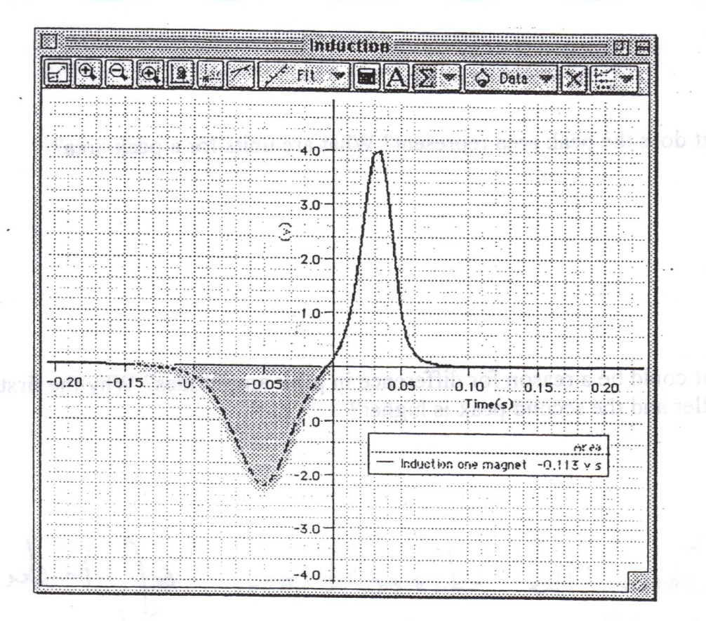

Figure 1: Computer generated graph of potential vs. time showing the induced EMF in a coil as a magnet drops through the coil.

The area under the curve ($ε∙Δt$) represents the change in flux (ΔФ) through the coil according to equation (3):

$$\begin{aligned}E⋆Δt=-N⋆ΔΦ\#\left(4\right)\end{aligned}$$

The area under the curve could be found by integration, and in this experimental set up, the integration will be done by the computer. Equation 4 allows one to define a magnetic flux and magnetic induction of a magnet.

In this experiment, you will plot a graph of the EMF versus time using the Universal Interface and Voltage Sensor. The computer is used as a measurement device which allows making measurements precisely and simultaneously plotting the induced voltage vs. time, as shown in figure 1. Induced EMF could be found from the graph by integrating the area under the curve.

## Experiment:

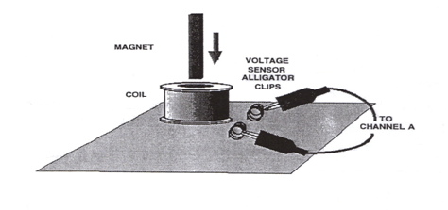***Set up:***

Figure 2: Experimental set up.

1. The set up for the experiment is shown on the Figure 2, and only includes a coil and a voltage sensor (no power supply – the changing flux is inducing EMF here).
   1. Connect the Voltage Sensor plug into channel “A”.
   2. Attach the Voltage Sensor leads to the coil.
   3. Take a sheet of paper and roll a tube that fits inside the coil, to guide the magnet through.
2. Open Pasco Capstone software.
   1. Click on “Hardware setup”.
   2. Look at the hardware; which plug is connected to the sensor?
   3. Click on the diagram of the hardware plug and scroll to voltage sensor and select.
   4. Click “Hardware setup” again to collapse this window
3. Choose table and graph for your experiment.
   1. Select what data you would like to have displayed.
   2. Your graph should have time on the x-axis and voltage on the y-axis.
4. Data recording should be set to 200 Hz. For this, look at the bottom of the screen for the box where you can adjust the recording frequency.
5. Use the Voltage Sensor to measure the voltage (emf) induced in the coil as a bar magnet moves through the coil. Use PASCO Capstone to record, display and analyze the data.
6. Place the coil on a tripod, so that a magnet dropped through the coil can fall free. **Make sure that the magnet does not strike the floor, or it may break or be destroyed.** Assigning one lab partner to run the computer, and another to drop and catch the magnet seems to work well.
7. Examine and notice which terminal of the coil is connected to the positive (“red”) voltage probe and which one is connected to the negative (“black”) voltage probe.
8. Use a compass or a ‘magnaprobe’ to check which pole of your bar magnet is “North”. Remember that the compass N-end of the arrow shows South-end of the magnet. The red end of the magnaprobe is north, so it is also attracted to the south pole of your magnet.

***Procedure:***

**Step 1. The North-End Magnet Drop**

1. Hold the bar magnet with the N pole facing downwards at a distance approximately 2 cm above the induction coil, ready to be dropped through the coil.
2. Start recording data by clicking on the Record icon, and let the magnet drop through the coil freely. Let the magnet freefall through the coil completely before you press the Stop button.
3. Repeat few times to get the best graph for analyzing the data. Save this graph (screen capture with axes labels, etc.). Notice the relative positions of a peak voltages and its height.
4. Set up your graph to show the area under the curve of voltage versus time. For this, click on .
5. Click on  to select a data range for the area of the first peak of the voltage plot. In PASCO Capstone, the value for ‘Area’ appears in the legend in the Graph. This is the flux through the coil (times the number of turns in the coil). (Right click on the ‘Area’ value to increase the number of digits displayed for higher precision.)
6. Record the magnitude of a peak EMF as $V_{max}$ and the value of area for the first peak in the Table 1 below.
7. Repeat the process to find the area under the second peak and record the value of integration for the second peak.
8. Compare the results of integration for both peaks by calculating the percent difference between them respect to the average.

$$\%\text{difference}=\frac{\left|\text{first peak area}\right|-|\text{second peak area}|}{\text{average peak magnitude}}×100\%$$

**Step 2. The South-End Magnet Drop**

1. Now hold the bar magnet with the South end facing downwards at a distance approximately 2 cm above the induction coil, ready to be dropped through the coil.
2. Start recording data, and then drop the magnet through the coil.
3. Observe the graph Voltage versus Time. Save a graph, noticing the relative positions of a peak voltages and its height.
4. Compare the graph with your experiment in Step 1 when the N-end dropped. Comment your observations in your discussion of the data. Notice differences and similarities.
5. Find the magnitude of the area under the first peak and record the value of integration for the first peak in a Table 2.
6. Repeat the process to find the area under the second peak and record the value of integration for the second peak in Table 2.
7. Compare the results of integration for both peaks and calculate the percent difference.

**Step 3. Flipping the Coil**

1. Flip the coil and drop the magnet with the South–end first from the same distance which is about 2 cm above the coil.
2. Go over the data recording and data analyzing procedure as in Step 2.
3. Save a graph, showing the relative positions of a peak voltages and its height and compare it with the previous graph in Step 2.
4. Record the results of integration for both peaks in the Table 3 and calculate the percent difference between the peaks.

**Step 4. Changing the Height of Drop**

1. With the same magnet and coil orientation as in Step 3, drop the magnet through the coil freely from the higher distance about 5 cm above the coil.
2. Go over data recording and data analyzing procedure as in previous experiments.
3. Save a graph EMF vs. time and compare it with the previous graphs
4. Record the results of measurement and calculation in the Table 4 and compare the results with previous experiment.

**Data and Computations:**

Include screen captures of graphs for Steps 1-4. Be sure that axes labels are visible with units of measurement. Title all graphs to distinguish them from one another.

Table 1 (North-end drop)

|  |  |  |  |
| --- | --- | --- | --- |
|  | Vmax [V] | Area [V*s] | % Difference |
| First Peak |  |  |  |
| Second Peak |  |  |
| Average Area = | |  |

**Take the absolute value of your Area measurement for all tables.**

Table 2 (South-end drop)

|  |  |  |  |
| --- | --- | --- | --- |
|  | Vmax [V] | Area [V*s] | % Difference |
| First Peak |  |  |  |
| Second Peak |  |  |
| Average Area = | |  |

Table 3. Flipping the coil

|  |  |  |  |
| --- | --- | --- | --- |
|  | Vmax [V] | Area [V*s] | % Difference |
| First Peak |  |  |  |
| Second Peak |  |  |
| Average Area = | |  |

Table 4 (A higher height drop)

|  |  |  |  |
| --- | --- | --- | --- |
|  | Vmax [V] | Area [V*s] | % Difference |
| First Peak |  |  |  |
| Second Peak |  |  |
| Average Area = | |  |

As the same bar magnet was used in each of the experiment in the Steps 1 through the Step 4, you can evaluate the magnetic induction ***B*** of the bar magnet. Combining equation 4 and equation 1 you have for *B*:

$$\begin{aligned}B=\frac{ℇΔt}{NA}\#\left(5\right)\end{aligned}$$

In this equation, $(ε ∆t)$ is “the area under the curve” which is equivalent to the flux through the coil, *N* is the number of turns in the coil, and *A* is the cross-section area of the coil.

When calculating magnetic induction ***B*** of the bar magnet, use the average values of the “areas under the curve” $\left(ε ∆t\right)$ from your experiments.

The coil with the AC/DC Electronics Lab has *N* = 600 turns of wire.

Measure the diameter *d* of the coil to calculate its cross section area *A*.

*d* = ________________

=_______________, m2

Consolidate the results of your calculations in a Table 5.

Table 5

|  |  |  |  |
| --- | --- | --- | --- |
|  | Average Area [V*s] | B [T] | ΔB from Average B [T] |
| Step 1 |  |  |  |
| Step 2 |  |  |  |
| Step 3 |  |  |  |
| Step 4 |  |  |  |
| Average B = | |  | $${σ }_{m}=$$ |

In the table above, $∆B=B_{i}-B_{av}$ is a deviation of a measured value $B_{i}$ from the average, where *i* is the number of steps which varies from 1 to 4 in your experiment;

σ*m* is the standard error of the mean: $σ_{m}=\sqrt{\frac{Σ{(∆B_{i})}^{2}}{n(n-1)}}$ where *n = 4*.

Represent the result of your experiment as two numbers (the average and standard deviation) $B =B_{av}±{σ }_{m}$:

**B = ______________________________________________**

**Analysis and Conclusions:**

**For Step 1, address these questions in your discussion:**

* Do both peak areas have to be the same or different? Explain your answer.
* What does the peak area represent? Are units for a peak area the same as for flux? Show that they are the same.
* What could be a reason for difference in peak amplitudes ${ V}_{max}$? Why is the first peak smaller and the second peak higher? [Hint: think about the speed of the magnet over time.]

**For Step 2, address these questions in your discussion:**

* Is the maximum voltage different for both peaks now? Which is higher? Why?
* Are the incoming and outgoing fluxes different for both peaks now?
* Compare the graph with your experiment in Step 1 when the N-end dropped. Comment your observations in your discussion of the data. Notice differences and similarities.
* Compare the results of integration with Step 1: if there is any significant difference in peak areas when S-end or N-end facing down when magnet is moving through the coil?

**For Step 3, address these questions in your discussion:**

* Does the graph have a similar appearance as in the Step 2 experiment with the same South-end drop? What is the difference? How does flipping the coil affect the results?
* Compare the results of your experiment in Step 3 with two previous experiments in Step 1 and Step 2.
* Is the maximum voltage different for both peaks now?
* Are incoming and outgoing fluxes affected by flipping the coil?
* Why are the peaks in opposite directions for each part of the experiment?

**For Step 4, address the following in your discussion:**

* How does the peak voltage change compared with the previous experiments? Why does a drop height affect a peak voltage?
* Does the flux change compared with the previous experiments?

**Sources of errors:**

What assumptions were made that caused error? What is the uncertainty in your final calculation due to measurement limitations?